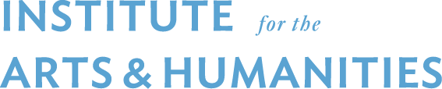

New Faculty Program Collaboration Grant

Deadline: February 28, 2022

The IAH Collaboration Grant began in 2017-2018 and provides funding to a participant of the New Faculty Program who collaborates with a more senior faculty member. Proposals for research projects that lead to a publication, creative activity, or a grant proposal will be prioritized. The program has a total of $5,000 and we may provide one or more grants depending on the quality and quantity of proposals.

ELIGIBILITY: The new faculty member should be the lead on the project. The funds can be used to pay for a graduate research assistant, travel to conduct research, supplies and materials to conduct research, or other research related activities. The funds cannot be used to support faculty salaries. Funds must be spent by June 30, 2023. Priority will be given to collaborations outside the home department and that lead to new faculty advancing their careers in their respective fields.

GENERAL INFORMATION (Please fill out):
- Applicant #1 Name:
Rank:
Department:
Email Address:
- Applicant #2 Name:
Rank:
Department:
Email Address:

EVENT/PROJECT INFORMATION
- Project Title:
- Proposed start date (MM/YYYY):
- Proposed end date (MM/YYYY):
- Describe the project in detail, including the purpose, goals, and output (300 words max).
- How will this project advance the career of the new faculty? (100 words max)
BUDGET/CAPACITY INFORMATION
- Please provide a brief budget including a narrative that explains/justifies how the funds will be spent.

- Do you have any additional funding sources to whom you have applied and/or confirmed support? If yes, please indicate how much and where the funding is coming from.

Please send application to ploth@email.unc.edu by 5pm on February 28. Awardees will be notified shortly thereafter. If you have any questions about the application, please contact Pam Lothspeich, NFP Program Director (ploth@email.unc.edu) or Philip Hollingsworth, IAH Program Administrator (pholling@email.unc.edu).

